AI ASSISTED CODING
LAB ASSIGNMENT-1.5
Name: K.Hemanth Kumar
Hall-ticket No: 2303A52320
Batch: 45

Task 1: AI-Generated Logic Without Modularization (String Reversal Without Functions)
Prompt:
# Implement a python program to reverse a string dynamically without using any user defined functions
Code:
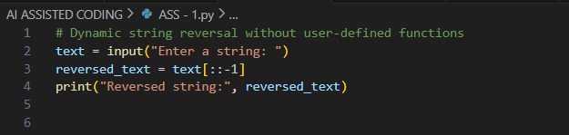
Output:
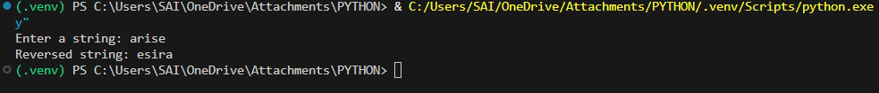
Justification:
The program performs string reversal using direct coding logic and does not involve any user-defined functions. It accepts the string at runtime. Because the entire logic is written in one place, the code is simple and easy to follow. This method is helpful for beginners to understand basic string operations.

Task 2: Efficiency & Logic Optimization (Readability Improvement)
Prompt:
# Write an optimized Python program to reverse a string
Code:
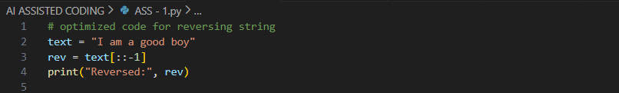
Output:
Justification:
The optimized code is simple and easy to understand.
It uses fewer variables and avoids complex index logic.
The string is reversed using a direct loop.
No functions are used, making the code clean and clear.

Task 3: Modular Design Using AI Assistance (String Reversal Using Functions)
Prompt:
# Implement a Python program to reverse a string dynamically by using functions and adding suitable comments
Code:
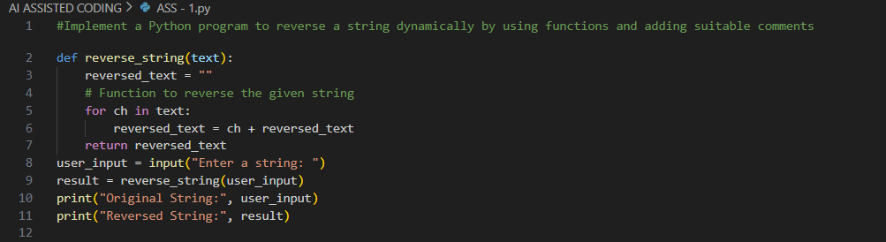
Output:

Justification:
Using a function to reverse a string keeps the code neat and structured. The function can be reused wherever needed, saving time and effort. It also makes the program easier to manage and fix when errors occur. This is especially useful in larger programs. AI-generated comments help readers understand the code easily.
Task 4: Comparative Analysis – Procedural vs Modular Approach (With vsWithout Functions)
Prompt:
# Write a Python program to reverse a string using two methods: without using a function and using a function. Implement both approaches clearly in the program. display a comparison table showing code clarity, reusability, debugging ease, and suitability for large applications for both methods.
Code:
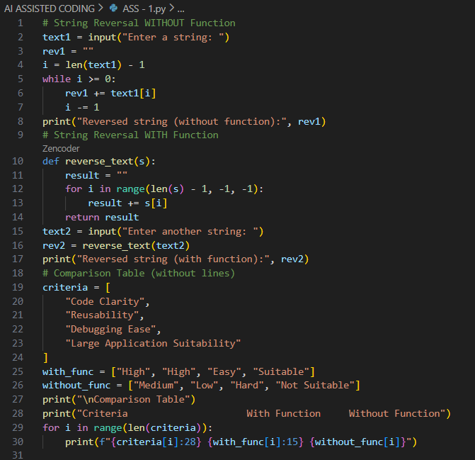
Output:

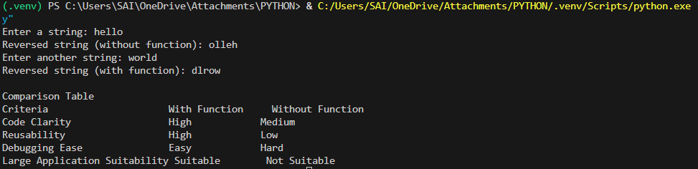
Justification:
The code is written without functions is easy for small programs because everything is in one place. But as the program gets bigger, it becomes hard to manage. Using functions keeps the code clean and reusable, and makes finding errors easier. So, functions are better for large programs
Task 5: AI-Generated Iterative vs Recursive Fibonacci Approaches (Different
Algorithmic Approaches to String Reversal)
Prompt:
#Implement a python program to print the string reversal in loop based approach and built in function with comparison of execution flow,time complexity,performance for large inputs and check the each approach is appropriate
Code:
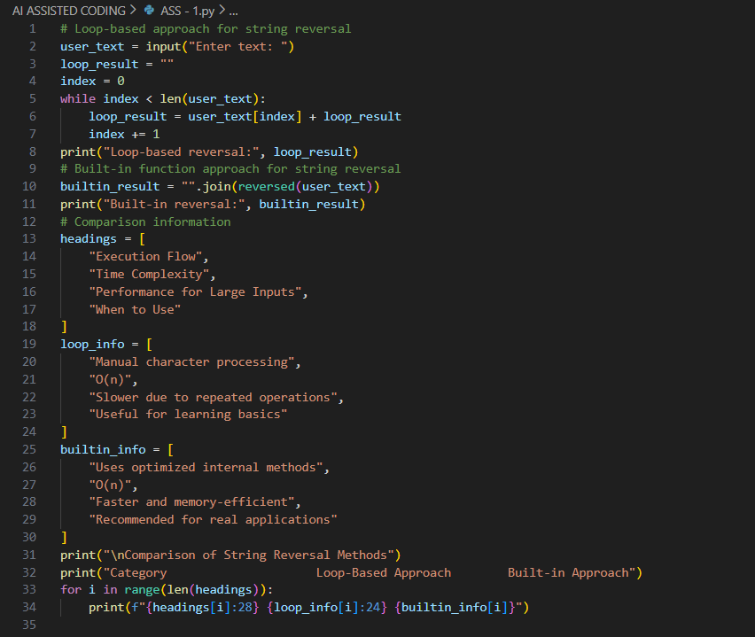
Output:

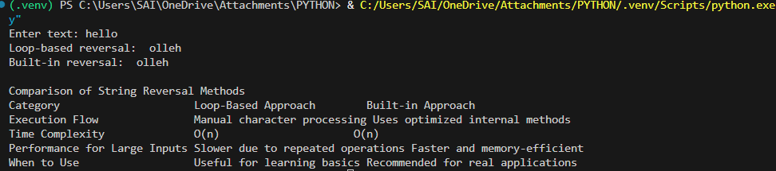
Justification:
The iterative method is easy to use and works well for large strings with less memory. It is faster and better for real applications. The recursive method is simple to understand but uses more memory and becomes slow for big inputs. So, iteration is better for performance, while recursion is good for learning.

